Name: Dodeja Yogesh Ghanshyambhai

Assignment: jquery Basic & Advance effects

1. **What is jQuery?**

* jQuery is a JavaScript Library.
* jQuery greatly simplifies JavaScript programming.
* jQuery is easy to learn.

1. **How to Apply CSS Using JQuery, How to Add Class**

**and Remove Class in Jquery , JQuery Animation?**

<!DOCTYPE html>

<html>

<head>

<script src="https://ajax.googleapis.com/ajax/libs/jquery/3.6.4/jquery.min.js"></script>

<script>

$(document).ready(function(){

$("button").click(function(){

alert("Background color = " + $("p").css("background-color"));

});

});

</script>

</head>

<body>

<h2>This is a heading</h2>

<p style="background-color:#ff0000">This is a paragraph.</p>

<p style="background-color:#00ff00">This is a paragraph.</p>

<p style="background-color:#0000ff">This is a paragraph.</p>

<button>Return background-color of p</button>

</body>

</html>

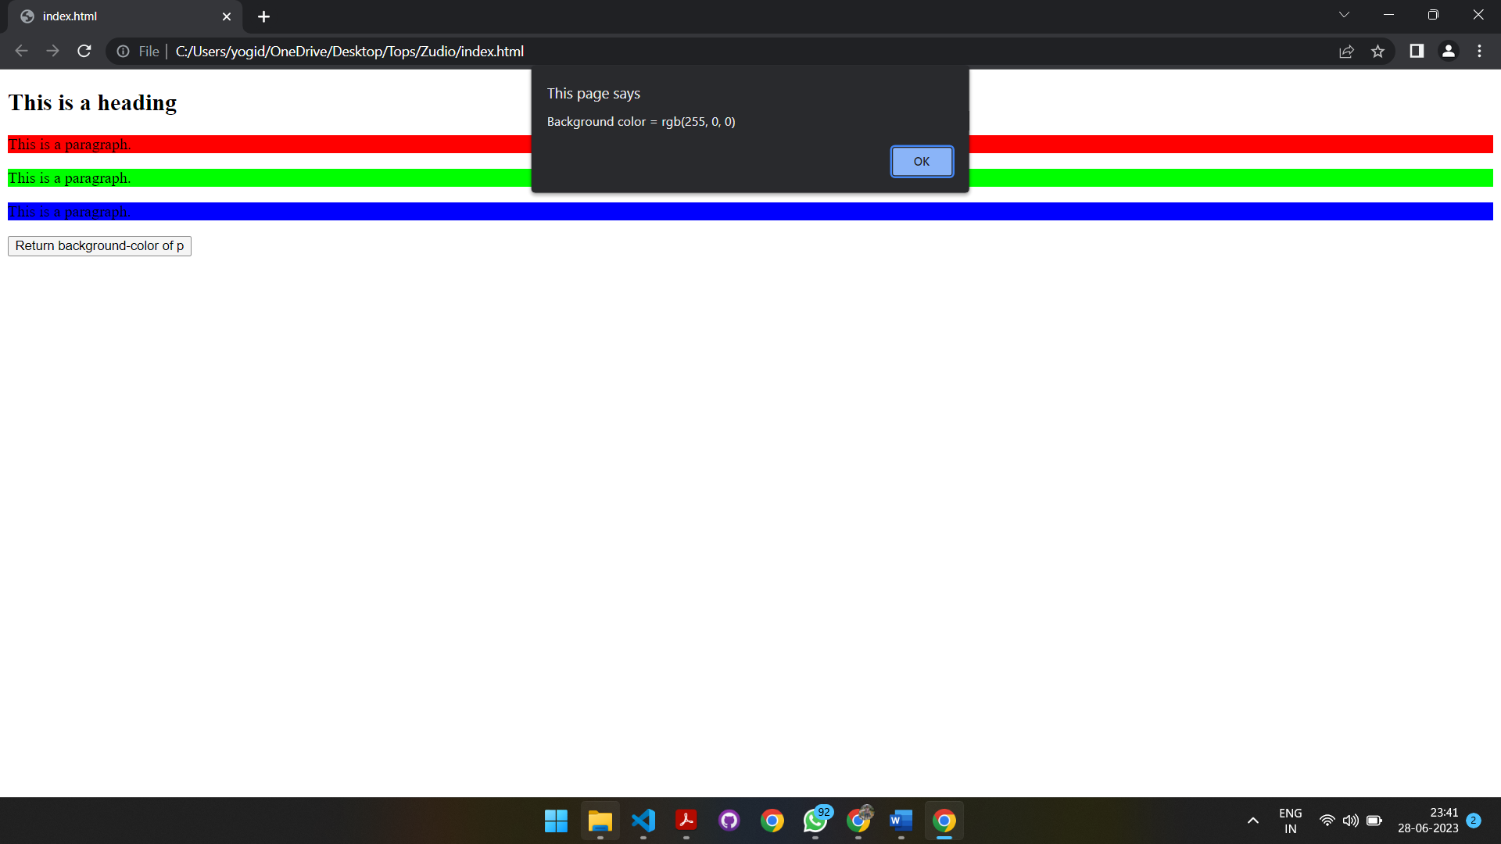Output :

**3.)How to create slider with animation?**

<!DOCTYPE html>

<html>

<head>

<script src="https://ajax.googleapis.com/ajax/libs/jquery/3.6.4/jquery.min.js"></script>

<script>

$(document).ready(function(){

$("#flip").click(function(){

$("#panel").slideUp("slow");

});

});

</script>

<style>

#panel, #flip {

padding: 5px;

text-align: center;

background-color: #e5eecc;

border: solid 1px #c3c3c3;

}

#panel {

padding: 50px;

}

</style>

</head>

<body>

<div id="flip">Click to slide up panel</div>

<div id="panel">Hello world!</div>

</body>

</html>

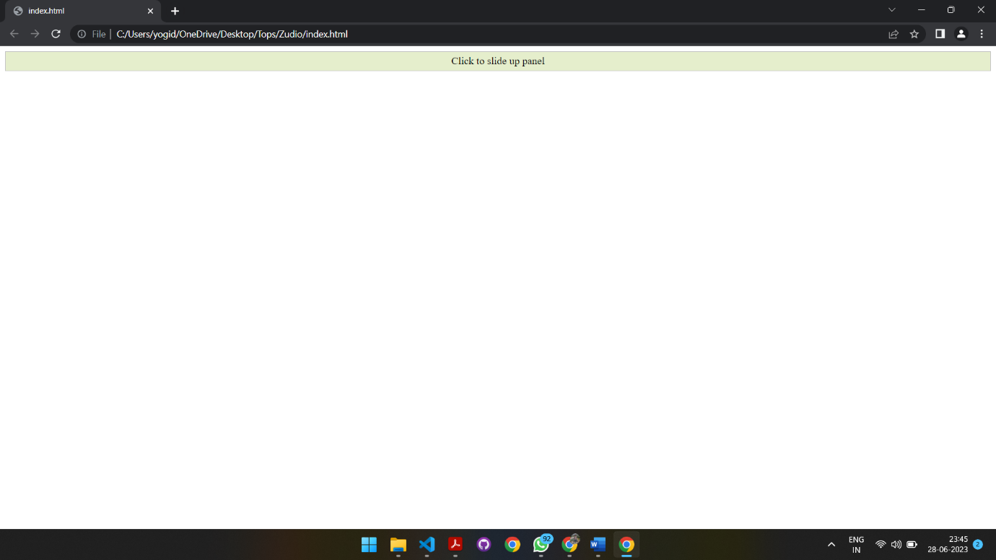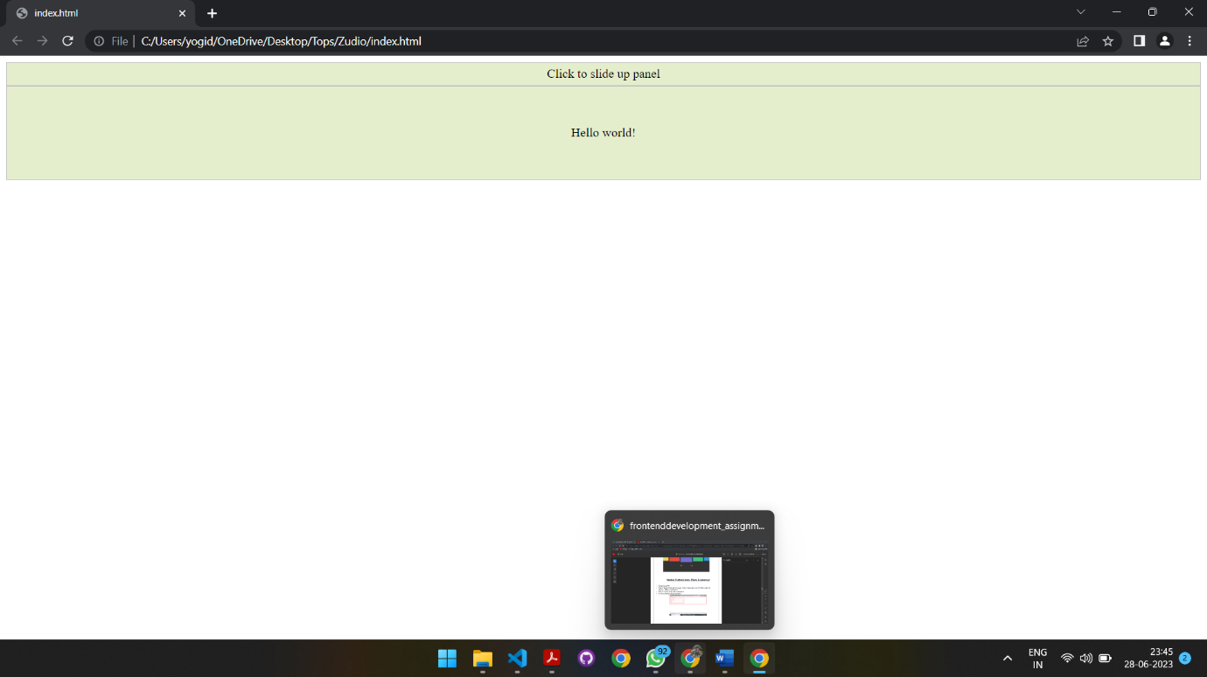**Output:**